2 | METHODS

2.1. Host-parasite system

The black spot disease is a common infection in marine and freshwater fishes caused by some Digenean trematodes (flukes) (Kurochkin & Biserova, 1996). Despite, some of these parasites (e.g., Posthodiplostomum cuticola, Uvulifer ambloplitis, Crassiphiala bulboglossa and Apophallus brevis) have been studied for a few decades, spatiotemporal infection patterns and their relation to environmental conditions are still elusive. Black spot causing trematodes all have a similar complex life cycle requiring a snail, a fish and a piscivorous bird as hosts (Figure 1). In the fish host, the parasite encysts under the skin, in the fins or the muscles (Hoffman, 1956; Krull, 1932, 1934) where it can survive in a dormant form for a few years (Hoffman & Putz, 1965) until the infected fish gets eaten by a bird. The distinctive black cyst results of the melanin pigment stimulation by the larva penetration in the fish body (Davis, 1967; Lemly & Esch, 1984). Because they have similar ecological requirements and cause the same symptoms in fishes, the black spot trematodes will be referred as a guild in the context of this study.

FIGURE 1

The typical lifecycle of a parasite species causing the black spot disease in freshwater fishes. A. The definitive host is a piscivorous bird, usually a kingfisher or a great blue heron. The metacercariae mature to its adult form and reproduce in the bird digestive system. B. The eggs are released in the water through the bird feces and grow into miracidia (first larval form). C. The miracidia infect the first intermediate host, a freshwater snail of Helisoma or Planorbella genus. The larvae develop into free-living stage cercariae (second larval form) and leave the snail. D. The cercariae swim until they encounter a potential fish host. E. The second intermediate host is a fish. The cercariae penetrate under the skin or the fins and transform in the metacercaria form. F. The fish is eaten by a definitive host.

Akin to other parasitic diseases, infection parameters of the black spot disease can vary across time, space, and species. For example, the infection prevalence in Bluegill sunfish (Lepomis macrochirus) inhabiting a pond reaches its minimum around April/May and its maximum around September/October (Lemly & Esch, 1984). The infection of fish-hosts necessarily imply that fish individuals and infected snail live in close habitats. Hence, infection levels in fish-host are usually higher is lentic rather lotic systems and in the littoral zone rather than pelagic zone (Ondrackova et al., 2004) because snails prefer shallow waters and generally feed on macrophytes (refs?). Because the black spot disease is caused by a parasite guild (so more than one trematode species), a large range of fishes can be infected. However, within a system, some species tend to be more heavily infected than others. For instance, Lemly & Esch (1984) found that bluegill sunfish were more heavily infected than largemouth bass (Micropterus salmoides).

2.2. Study area

We sampled 15 lakes from six watersheds in Saint-Hippolyte, QC, Canada (Figure 2). The lakes Corriveau, Croche, Cromwell and Triton are located in the protected area of the biology station of the Université de Montréal while the other lakes are surrounded by private properties. Considering their geographical proximity, we assumed that all the lakes are exposed to the same climatic conditions. The lakes were selected nonrandomly according to the accessibility of the site and the availability of morphometric data (see Table S1).
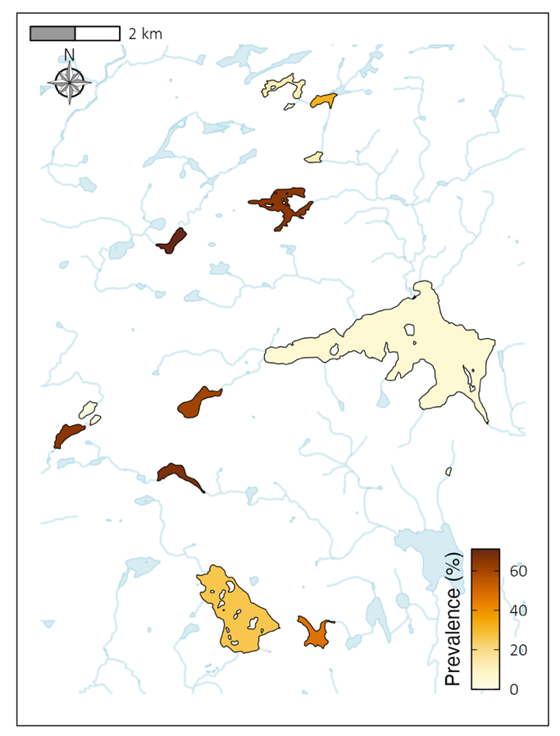

FIGURE 2

Map of the study area. The lakes sampled are colored according to the black spot disease infection prevalence in the local fish communities in the littoral zone. The data used to estimate infection prevalence comes from all the sampling methods combined.

2.3. Data acquisition

Three sampling methods were used to assess prevalence infection and maximize the chances of catching species richness. The field work took place from mid-June to end of August 2022 and was restricted to unrainy days to limit sampling bias due to meteorological effects.
The number of samplings for each lake was stated according to the lake area except for minnow traps (Table S2). As it requires less time and manipulations, all the 15 minnow traps were set in each lake to maximize the number of captures. Fishing gear dimensions are available in Table S3. All the fishing gear was cleaned between lakes following MFFP recommendations to prevent exotic species contamination. Animal handling was approved by the Université de Montréal’s animal care committee (protocol number 22-025) and scientific fishing permit was delivered by the Ministère des Forêts, de la Faune et des Parcs (MFFP) of Québec (2022-05-16-1971-15-S-P).
Minnow trap and seine net samplings were both done on the same day for each lake. The seine samplings occurred during the daytime in habitats lacking big obstacles like trunks and large rocks in which the net can get stuck. Two sizes of minnow traps were set at approximately equal distance along the shore, from 4PM to 8PM, to target species that are most active at dusk. There were no habitat restrictions for the minnow traps emplacement. Half of the traps were baited (3 large and 5 small traps) to sample various feeding preferences and habits.
All fishes were counted, identified to species level, and measured (estimation of the total length to the nearest centimeter) directly after capture and released afterwards. Northern redbelly dace (Chrosomus eos) and finescale dace (Chrosomus neogaeus) individuals were identified as Chrosomus spp. as the two species hybrid in our system and cannot be distinguished based on morphology in the field (Leung et al., 2017). The presence of black cysts was assessed on the left side of the fish (De Bonville, in prep.). Juveniles and adults were considered in this study as all individuals are vulnerable to the black spot disease.
Fifty meters snorkeling transects along the shore were conducted to assess black spot infection in the fish community. Due to time constraints, lakes Beaver, Montaubois, Tracy and St-Onge were excluded of transect sampling because of low fish abundance in the fishing samplings or poor water clearness. We selected site emplacements that were approximately between 0.5 and 3.0 m deep, not fully covered by macrophytes, not obstructed by docks and preferably with some vegetal, rock or trunk refuges for the fishes. The sites were picked and flagged every ten meters at the end-May 2022. The transects were performed by two observers at the time covering each a one-meter radius field of view and moving forward at a pace of three minutes by ten meters. The fishes coming in the field of view from behind the observer were not counted. All the fishes were identified to the lower taxonomic level possible and black spot infection was noted. All cyprinids were grouped into the same category given that they are more difficult to identify at the species level and usually move faster.

Following the prevalence transect assessment, we conducted the description of the habitat characteristics. The percentage of substrate categories (silt, sand, rock, and metric block), the coverage of macrophytes, the number of trunks (or large branch), and the mean depth was estimated for each 10-meter segment. The temperature, the dissolved oxygen, the conductivity and the pH were measured at mid-depth at the beginning of every transect with a YSI ProDSS Multi-Parameter Water Quality Meter. 1 L of unfiltered water was taken at mid-depth in previously acid-washed HDPE bottle for carbon and nutrients content analysis. The samples were placed in a dark cooler until brought back to the laboratory where the 1 L samples were separated in previously acid-washed 40 mL vials for total organic carbon (TOC), and 500 mL HDPE bottle for total nitrogen (TN) and total phosphorus (TP). TOC samples were placed in a 4°C refrigerator until analyze within the week while TN/TP samples were kept in a -20°C freezer until later processing.

2.3. System description

We recorded a total of 11 297 individuals belonging to 15 species for this study (Table S4).
The minnow traps caught 1906 individuals from 10 species while seine nets caught 2427 individuals from 14 species (Table S5 and S6). 6964 individuals belonging to five taxonomic groups (four species and one family) were observed in snorkeling transects (Table S7). The mean length of all fish captured through fishing methods was 5.59 ± 2.96 cm (N = 4333). The overall mean length of each lake, species and, species within each lake are presented in Table S8, S9 and S10.

In the context of this study, the infection prevalence is estimated as the number of infected individuals by a species of the black spot guild, divided by the total number of individuals in a given fish community. All fishes species in our lake system, except for Ameiurus nebulosus and Esox masquinongy are susceptible to the black spot disease (see Table S11). Based on the data from all the sampling methods, the regional community prevalence is 29.39 %, local (i.e., lake) prevalence vary between 0% and 71% (Table S12) and fine-scale prevalence (i.e., transects) vary between 0% and 100% (Table S13). Our survey corroborates black spot infection in Lepomis gibbosus, Ambloplites rupestris, Perca flavescens, Micropterus dolomieu, Semotilus atromaculatus and Pimephales promelas.

TOC sample contents were measured on Siervers M5310 C Laboratory Total Organic Carbon Analyzer. TN and TP samples were oxidized with persulfate into the autoclave the day before analysis (EPA353.2; EPA365.3). TN concentrations were measured on a Lachat QuikChem 8500 analyzer (EPA353.2) and TP concentrations were analyzed on a Asoria-Pacific Astoria2 (EPA365.3). Results for TN and TP concentrations are presented in Table S14 along with physico-chemistry measurements. Mean habitat descriptions are presented in Table S15 for each transect.

2.4. Statistical methods

To describe the black spot prevalence pattern across multiple scales, we employed the following procedures. All the data manipulations and analysis were conducted on RStudio (Version 2023.06.2+561). Lake Tracy was excluded from analysis because of low abundance data (N = 1).

For the regional-scale analysis, we wanted to look at the effect of the sampling design (here the sampling method and the number of samplings) in the estimation of a regional prevalence. We used a resampling approach on the data from different sampling methods (minnow trap, seine nets, transects and all methods combined) to visualize the accumulation of i) the infected individuals, ii) the total individuals and, ii) the infection prevalence through an increasing sampling gradient. The number of samplings (N) was set at N = c(1, 2, 3, 5, 7, 10, 15, 20, 25, 35) not to exceed the actual number of samplings (smallest to be 39 samplings for the transect method). The abundance data (infected and total individuals) was pooled together, and the prevalence was calculated for every sampling. The data set was then split according to the sampling method. N random samples were drafted from the pooled data and, for the infected and total individuals, the sum was calculated while the mean was calculated for the prevalence. The operation was replicated 999 times for each N and sampling methods. A linear regression was then fitted to the mean of every value sampled for each number of samplings.

For the local-scale analysis, we examined the frequency distribution of the lakes’ prevalence according to the sampling method. The mean infection prevalence was previously calculated, and visualization was made with histograms.

For the fine-scale analysis, we modeled the relations between the environmental variables and the infection prevalence on a transect level. We used generalized additive mixed-effect models (GAMMs) from the mgcv package with a quasi-binomial distribution, a maximum likelihood estimation and the lake as a random factor. Because of the small sample size (N = 39), we included only one environmental variable at the time to save degrees of freedom. The model validations were conducted with gratia package. The visualization of the partial effects was made with gratia and ggplot2 package.

